# STEFANIK SCORECARDS

## ABORTION

### STEFANIK RECEIVED MULTIPLE 0% RATINGS FROM PLANNED PARENTHOOD

#### 2025: STEFANIK RECEIVED A 3% RATING FROM PLANNED PARENTHOOD

**2025: Stefanik Received A 3% Rating From Planned Parenthood.** [Planned Parenthood, Congressional Scorecard, Accessed [8/22/25](https://www.plannedparenthoodaction.org/congressional-scorecard)]

[Planned Parenthood, Congressional Scorecard, Accessed [8/22/25](https://www.plannedparenthoodaction.org/congressional-scorecard)]

#### 2023-2024: STEFANIK RECEIVED A 0% RATING FROM PLANNED PARENTHOOD

**2023-2024: Stefanik Received A 0% Rating From Planned Parenthood.** [Planned Parenthood, Congressional Scorecard, Accessed [9/2/25](https://www.plannedparenthoodaction.org/congressional-scorecard)]





[Planned Parenthood, Congressional Scorecard, Accessed [9/2/25](https://www.plannedparenthoodaction.org/congressional-scorecard)]

#### 2021-2022: STEFANIK RECEIVED A 0% RATING FROM PLANNED PARENTHOOD

**2021-2022: Stefanik Received A 0% Rating From Planned Parenthood.** [Planned Parenthood, Congressional Scorecard, Accessed [9/2/25](https://www.plannedparenthoodaction.org/congressional-scorecard)]





[Planned Parenthood, Congressional Scorecard, Accessed [9/2/25](https://www.plannedparenthoodaction.org/congressional-scorecard)]

#### 2019-2020: STEFANIK RECEIVED AN 11% RATING FROM PLANNED PARENTHOOD

**2019-2020:** **Stefanik Received An 11% Rating From Planned Parenthood.** [Planned Parenthood, Congressional Scorecard, Accessed [9/2/25](https://www.plannedparenthoodaction.org/congressional-scorecard)]





[Planned Parenthood, Congressional Scorecard, Accessed [9/2/25](https://www.plannedparenthoodaction.org/congressional-scorecard)]

### STEFANIK RECEIVED A LIFETIME RATING OF 96% FROM THE NATIONAL RIGHT TO LIFE

**Overall: Stefanik Received A 96% Rating From National Right To Life.** [National Right to Life, Action Center, Accessed [9/2/25](https://www.votervoice.net/NRLC/Scorecard#/?page=scorecard-59706)]

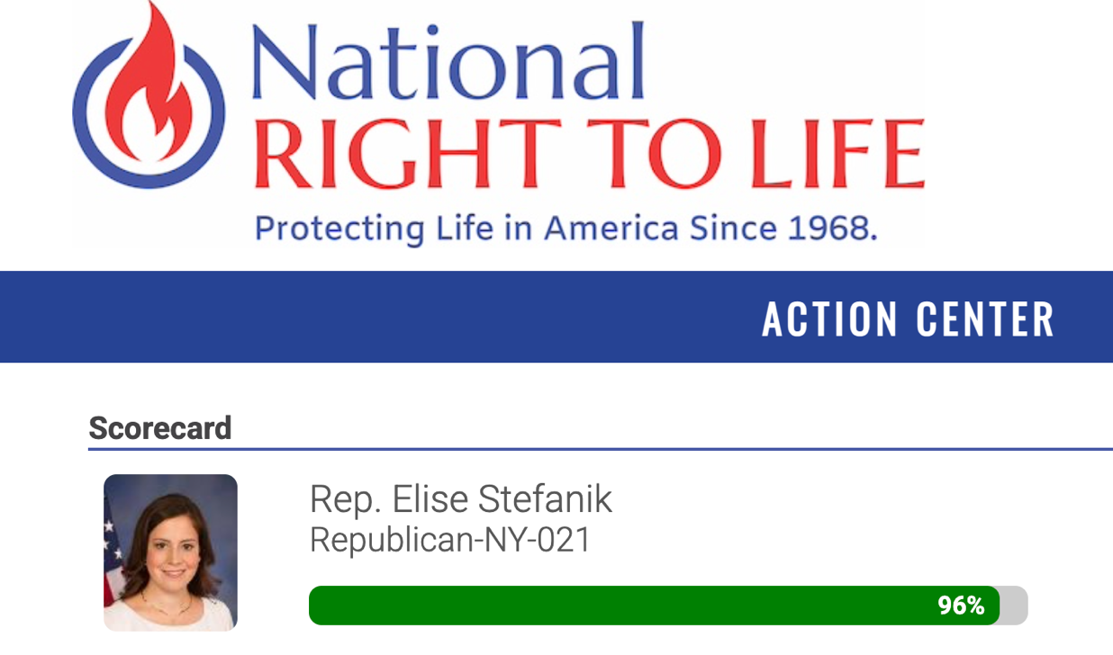

[National Right to Life, Action Center, Accessed [9/2/25](https://www.votervoice.net/NRLC/Scorecard#/?page=scorecard-59706)]

#### 2025: STEFANIK RECEIVED A 100% RATING FROM NATIONAL RIGHT TO LIFE

**2025-2026: Stefanik Received A 100% Rating From National Right To Life.** [National Right to Life, Action Center, Accessed [9/2/25](https://www.votervoice.net/NRLC/Scorecard#/?page=scorecard-59706)]

[National Right to Life, Action Center, Accessed [9/2/25](https://www.votervoice.net/NRLC/Scorecard#/?page=scorecard-59706)]

#### 2023-2024: STEFANIK RECEIVED A 100% RATING FROM NATIONAL RIGHT TO LIFE

**2023-2024: Stefanik Received A 100% Rating From National Right To Life.** [National Right to Life, Action Center, Accessed [9/2/25](https://www.votervoice.net/NRLC/Scorecard#/?page=scorecard-59706)]

[National Right to Life, Action Center, Accessed [9/2/25](https://www.votervoice.net/NRLC/Scorecard#/?page=scorecard-59706)]

#### 2021-2022: STEFANIK RECEIVED A 100% RATING FROM NATIONAL RIGHT TO LIFE

**2021-2022: Stefanik Received A 100% Rating From National Right To Life.** [National Right to Life, Action Center, Accessed [9/2/25](https://www.votervoice.net/NRLC/Scorecard#/?page=scorecard-59706)]

[National Right to Life, Action Center, Accessed [9/2/25](https://www.votervoice.net/NRLC/Scorecard#/?page=scorecard-59706)]

#### 2019-2020: STEFANIK RECEIVED An 87.5% RATING FROM NATIONAL RIGHT TO LIFE

**2019-2020: Stefanik Received An 87.5% Rating From National Right To Life.** [National Right to Life, Action Center, Accessed [9/2/25](https://www.votervoice.net/NRLC/Scorecard#/?page=scorecard-59706)]

[National Right to Life, Action Center, Accessed [9/2/25](https://www.votervoice.net/NRLC/Scorecard#/?page=scorecard-59706)]

#### 2017-2018: STEFANIK RECEIVED A 100% RATING FROM NATIONAL RIGHT TO LIFE

**2017-2018: Stefanik Received A 100% Rating From National Right To Life.** [National Right to Life, Action Center, Accessed [9/2/25](https://www.votervoice.net/NRLC/Scorecard#/?page=scorecard-59706)]

[National Right to Life, Action Center, Accessed [9/2/25](https://www.votervoice.net/NRLC/Scorecard#/?page=scorecard-59706)]

### Stefanik received MULTIPLE A+ ratingS from the extreme anti-abortion group Susan B. Anthony List

#### 2023-2024: STEFANIK RECEIVED AN A+ RATING FROM THE SUSAN B. ANTHONY LIST

**2023-2024: Stefanik Received An A+ Rating From The Susan B. Anthony List.** [Susan B. Anthony List, Rep. Elise Stefanik, Accessed, [8/22/25](https://sbaprolife.org/representative/elise-stefanik)]

[Susan B. Anthony List, Rep. Elise Stefanik, Accessed [8/22/25](https://sbaprolife.org/representative/elise-stefanik)]

**2023-2024: Susan B. Anthony List Praised Stefanik For Voting “Consistently To Defend The Lives Of The Unborn And Infants” By Stopping “Tax Dollars From Paying For Abortion” And “Pushing Back On The Biden-Harris Administration’s Extreme Executive Actions On Abortion.”** SUSAN B. ANTHONY LIST: “Rep. Stefanik, who serves as Republican Conference Chair, has stood up against the ever-growing pro-abortion agenda of the Biden-Harris administration and the radical bureaucrats who are actively working to expand abortion access, resources, and funding. Rep. Stefanik has voted consistently to defend the lives of the unborn and infants. This includes stopping hard-earned tax dollars from paying for abortion, including abortion travel expenses, whether domestically or internationally, and pushing back on the Biden-Harris administration’s extreme executive actions on abortion.” [Susan B. Anthony List, Rep. Elise Stefanik, Accessed, [8/22/25](https://sbaprolife.org/representative/elise-stefanik)]

**2023-2024: Susan B. Anthony Pro-Life America’s Mission Was “To End Abortion” Throughout The United States By Electing National Leaders And Advocating For Anti-Abortion Legislation.** “SBA Pro-Life America's mission is to end abortion by electing national leaders and advocating for laws that save lives, with a special calling to promote pro-life women leaders. […] Our full family of organizations is united in the singular mission of saving innocent and vulnerable human life. We work cooperatively to meet the pro-life movement’s need to maximize election outcomes, and to enhance policy research and education for policymakers and the public.” [Susan B. Anthony List, Rep. Elise Stefanik, Accessed [8/22/25](https://sbaprolife.org/about)]

#### 2021-2022: STEFANIK RECEIVED AN A+ RATING FROM THE SUSAN B. ANTHONY LIST

**2021-2022: Stefanik Received An A+ Rating From The Susan B. Anthony List.** [Susan B. Anthony List, Rep. Elise Stefanik, Accessed, [9/2/25](https://sbaprolife.org/representative/elise-stefanik)]

[Susan B. Anthony List, Rep. Elise Stefanik, Accessed, [9/2/25](https://sbaprolife.org/representative/elise-stefanik)]

**2021-2022: Susan B. Anthony Pro-Life Said That Stefanik Opposed Taxpayer Funding For Abortion.** “Congresswoman Stefanik has stood up against the pro-abortion agenda of the Biden-Harris administration and Pelosi Democrats who are actively working to expand abortion access and abortion funding. Rep. Stefanik has voted consistently to defend the lives of the unborn and infants. This includes stopping hard-earned tax dollars from paying for abortion, whether domestically or internationally, and protecting health care provider rights for those who refuse to engage in brutal abortions.” [Susan B. Anthony List, Rep. Elise Stefanik, Accessed, [9/2/25](https://sbaprolife.org/representative/elise-stefanik)]

**2021-2021: Susan B. Anthony Pro-Life Said That Stefanik Would Protect Health Care Providers That Refused To Engaged In Abortions.** “Congresswoman Stefanik has stood up against the pro-abortion agenda of the Biden-Harris administration and Pelosi Democrats who are actively working to expand abortion access and abortion funding. Rep. Stefanik has voted consistently to defend the lives of the unborn and infants. This includes stopping hard-earned tax dollars from paying for abortion, whether domestically or internationally, and protecting health care provider rights for those who refuse to engage in brutal abortions.” [Susan B. Anthony List, Rep. Elise Stefanik, Accessed, [9/2/25](https://sbaprolife.org/representative/elise-stefanik)]

#### 2019-2020: STEFANIK RECEIVED A B RATING FROM THE SUSAN B. ANTHONY LIST

**2019-2020: Stefanik Received A B Rating From The Susan B. Anthony List.** [Susan B. Anthony List, Rep. Elise Stefanik, Accessed, [9/2/25](https://sbaprolife.org/representative/elise-stefanik)]

[Susan B. Anthony List, Rep. Elise Stefanik, Accessed, [9/2/25](https://sbaprolife.org/representative/elise-stefanik)]

## ConservAtive

### 2024: Club for Growth gave Stefanik A Rating Of 70

**2024: Club for Growth Foundation Gave Stefanik A Rating Of 70 With A Lifetime Score Of 51.** As Of August 2025, Stefanik’s Club for Growth Foundation 2024 score a rating of 70. With a lifetime score of 51, ranking 101.[Club for Growth, accessed, [8/22/25](https://www.clubforgrowth.org/scorecards/legislator/S001196/Elise-Stefanik/)]

[Club for Growth, accessed [8/22/25](https://www.clubforgrowth.org/scorecards/legislator/S001196/Elise-Stefanik/)]

### 2024: Heritage Action For America gave Stefanik A Rating Of 60%

**2023-2024: Heritage Action Gave Stefanik A Rating Of 60% For The 118th Congressional Session With A Lifetime Score Of 51%, Compared To The Average House Republican Score Of 74%.** As Of August 2025, t Heritage Action gave Stefanik a rating of 60%. With a lifetime score of 51%.[Heritage Action, accessed [8/22/25](https://heritageaction.com/scorecard/members/S001196/118)]

[Heritage Action, accessed [8/22/25](https://heritageaction.com/scorecard/members/S001196/118)]

## EnviroNment

### STEFANIK RECEIVED MULTIPLE 0% RATINGS FROM THE LEAGUE OF CONSERVATION VOTERS

#### 2024: The League of Conservation Voters gave Stefanik A Rating Of 0%

**2024: The League Of Conservation Voters Gave Stefanik A Rating Of 0% With A Lifetime Score Of 26%.** As Of August 2025, the League of Conservation Voters gave Stefanik a rating of 0%. With a lifetime score of 26%.[LCV, accessed, [8/22/25](https://www.lcv.org/moc/elise-stefanik/)]

[LCV, accessed [8/22/25](https://www.lcv.org/moc/elise-stefanik/)]

#### 2023: The League of Conservation Voters gave Stefanik A Rating Of 0%

**2023: The League Of Conservation Voters Gave Stefanik A Rating Of 0% Based On 0 Pro-environment votes And 31 Anti-Environment Votes.** [LCV, accessed, [8/22/25](https://www.lcv.org/moc/elise-stefanik/)]

[LCV, accessed [8/22/25](https://www.lcv.org/moc/elise-stefanik/)]

#### 2022: The League of Conservation Voters gave Stefanik A Rating Of 11%

**2022: The League Of Conservation Voters Gave Stefanik A Rating Of 11% Based On 2 Pro-environment Votes And 17 Anti-Environment Votes.** [LCV, accessed [8/22/25](https://www.lcv.org/moc/elise-stefanik/)]

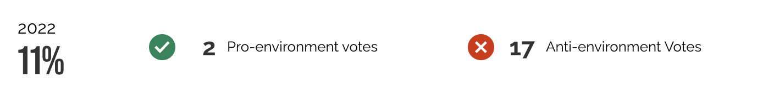

[LCV, accessed [8/22/25](https://www.lcv.org/moc/elise-stefanik/)]

#### 2021: The League of Conservation Voters gave Stefanik A Rating Of 13%

**2021: The League Of Conservation Voters Gave Stefanik A Rating Of 13% Based On 3 Pro-environment Votes And 20 Anti-Environment Votes.** [LCV, accessed [8/22/25](https://www.lcv.org/moc/elise-stefanik/)]

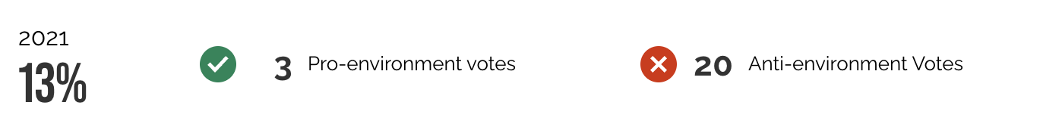

[LCV, accessed [8/22/25](https://www.lcv.org/moc/elise-stefanik/)]

#### 2020: The League of Conservation Voters gave Stefanik A Rating Of 48%

**2020: The League Of Conservation Voters Gave Stefanik A Rating Of 48% Based On 10 Pro-environment Votes And 11 Anti-Environment Votes.** [LCV, accessed [8/22/25](https://www.lcv.org/moc/elise-stefanik/)]

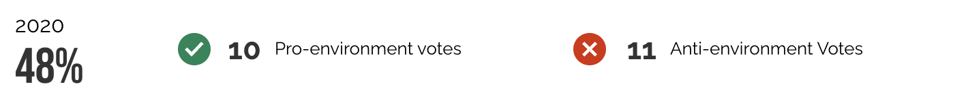

[LCV, accessed [8/22/25](https://www.lcv.org/moc/elise-stefanik/)]

#### 2019: The League of Conservation Voters gave Stefanik A Rating Of 55%

**2019: The League Of Conservation Voters Gave Stefanik A Rating Of 55% Based On 16 Pro-environment Votes And 13 Anti-Environment Votes.** [LCV, accessed [8/22/25](https://www.lcv.org/moc/elise-stefanik/)]

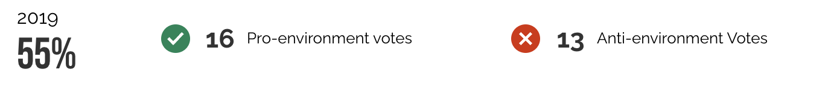

[LCV, accessed [8/22/25](https://www.lcv.org/moc/elise-stefanik/)]

#### 2018: The League of Conservation Voters gave Stefanik A Rating Of 51%

**2018: The League Of Conservation Voters Gave Stefanik A Rating Of 51% Based On 18 Pro-environment Votes And 17 Anti-Environment Votes.** [LCV, accessed [8/22/25](https://www.lcv.org/moc/elise-stefanik/)]

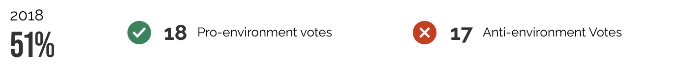

[LCV, accessed [8/22/25](https://www.lcv.org/moc/elise-stefanik/)]

#### 2017: The League of Conservation Voters gave Stefanik A Rating Of 43%

**2017: The League Of Conservation Voters Gave Stefanik A Rating Of 43% Based On 15 Pro-environment Votes And 20 Anti-Environment Votes.** [LCV, accessed [8/22/25](https://www.lcv.org/moc/elise-stefanik/)]

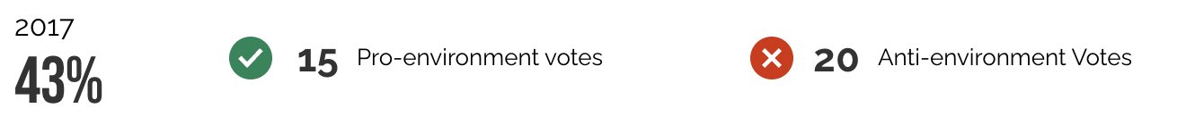

[LCV, accessed [8/22/25](https://www.lcv.org/moc/elise-stefanik/)]

#### 2016: The League of Conservation Voters gave Stefanik A Rating Of 29%

**2016: The League Of Conservation Voters Gave Stefanik A Rating Of 29% Based On 11 Pro-environment Votes And 27 Anti-Environment Votes.** [LCV, accessed [8/22/25](https://www.lcv.org/moc/elise-stefanik/)]

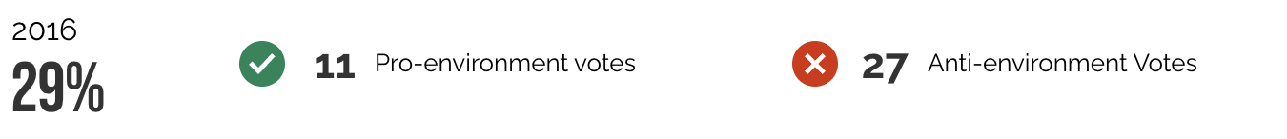

[LCV, accessed [8/22/25](https://www.lcv.org/moc/elise-stefanik/)]

#### 2015: The League of Conservation Voters gave Stefanik A Rating Of 9%

**2015: The League Of Conservation Voters Gave Stefanik A Rating Of 9% Based On 3 Pro-environment Votes And 32 Anti-Environment Votes.** [LCV, accessed [8/22/25](https://www.lcv.org/moc/elise-stefanik/)]



[LCV, accessed [8/22/25](https://www.lcv.org/moc/elise-stefanik/)]

## GUNS

### 2014-2024: STEFANIK received ONLY A AND A+ RATINGS FROM THE NRA WHILE IN CONGRESS

#### 2024: STEFANIK WAS ENDORSED BY THE NRA AND RECEIVED AN “A+” RATING

**2024: Stefanik Was Endorsed By The NRA And Received An A+ Rating.** [NRA-PVF, New York, Archived [11/5/24](https://web.archive.org/web/20241105060732/https:/www.nrapvf.org/grades/New-York/)]

[NRA-PVF, New York, Archived [11/5/24](https://web.archive.org/web/20241105060732/https:/www.nrapvf.org/grades/New-York/)]

#### 2022: STEFANIK WAS ENDORSED BY THE NRA AND RECEIVED AN “A+” RATING

**2022: Stefanik Was Endorsed By The NRA And Received An A+ Rating.** [NRA-PVF, New York, Archived [11/5/22](https://web.archive.org/web/20221105083104/https:/www.nrapvf.org/grades/New-York/)]

[NRA-PVF, New York, Archived [11/5/22](https://web.archive.org/web/20221105083104/https:/www.nrapvf.org/grades/New-York/)]

#### 2020: STEFANIK WAS ENDORSED BY THE NRA AND RECEIVED AN “A+” RATING

**2020: Stefanik Was Endorsed By The NRA And Received An A+ Rating** [NRA-PVF, New York, Archived [11/3/20](https://web.archive.org/web/20201103183759/https:/www.nrapvf.org/grades/New-York/)]

[NRA-PVF, New York, Archived [11/3/20](https://web.archive.org/web/20201103183759/https:/www.nrapvf.org/grades/New-York/)]

2018: STEFANIK WAS ENDORSED BY THE NRA AND RECEIVED AN “A” RATING

**2018:** **The National Rifle Association Shared An Email That Said That Stefanik Was “A” Rated And NRA-PVF Endorsed.** [NRA-PVF, Email, Accessed [9/2/25](https://www.nrapvf.org/emails/2018/new-york/elise-stefanik-ny-21-general-election-email/)]

[NRA-PVF, Email, Accessed [9/2/25](https://www.nrapvf.org/emails/2018/new-york/elise-stefanik-ny-21-general-election-email/)]

2016: STEFANIK WAS ENDORSED BY THE NRA AND RECEIVED AN “A” RATING

**2016: Stefanik Was Endorsed By The NRA And Received An A Rating.** [NRA-PVF, New York, Archived [10/29/16](https://web.archive.org/web/20161029013116/https:/www.nrapvf.org/grades/New-York/)]

[NRA-PVF, New York, Archived [10/29/16](https://web.archive.org/web/20161029013116/https:/www.nrapvf.org/grades/New-York/)]

#### 2014: STEFANIK RECEIVED AN “A-QUESTIONABLE” RATING FROM THE NRA

**2014: Stefanik Received An A-Questionable Rating From The NRA.** [NRA-PVF, New York, Archived [11/4/14](https://web.archive.org/web/20141104194224/https:/www.nrapvf.org/grades/New-York/)]

[NRA-PVF, New York, Archived [11/4/14](https://web.archive.org/web/20141104194224/https:/www.nrapvf.org/grades/New-York/)]

*\*Note: Stefanik was not endorsed by the NRA in 2014.*

### 2018-2024: STEFANIK RECEIVED “A+” ANd 100% RATINGS FROM THE NATIONAL SHOOTING SPORTS FOUNDATION

#### 2024: Stefanik received an “A+” rating from the National Shooting Sports Foundation

**2024: The NSSF Gave Stefanik An A+ Rating On The Congressional Report Card.** [NSSF,2024 Congressional Report Card,Accessed [8/28/24](https://www.nssf.org/wp-content/uploads/2024/09/2024-NSSF-Congressional-Reportcard.pdf)]



[NSSF,2024 Congressional Report Card,Accessed [8/28/24](https://www.nssf.org/wp-content/uploads/2024/09/2024-NSSF-Congressional-Reportcard.pdf)]

#### 2022: Stefanik received an “A+” rating from the National Shooting Sports Foundation

**2022: The NSSF Gave Stefanik An A+ Rating On The Congressional Report Card.** [NSSF, 2022 Congressional Report Card, Accessed [9/3/25](https://www.nssf.org/wp-content/uploads/2022/09/2022-NSSF-Congressional-Reportcard.pdf)]



[NSSF, 2022 Congressional Report Card, Accessed [9/3/25](https://www.nssf.org/wp-content/uploads/2022/09/2022-NSSF-Congressional-Reportcard.pdf)]

#### 2020: Stefanik received an “A+” rating from the National Shooting Sports Foundation

**2020: The NSSF Gave Stefanik An A+ Rating On The Congressional Report Card.** [NSSF, 2020 Congressional Report Card, Accessed [9/3/25](https://www.nssf.org/wp-content/uploads/2020/10/2020-Report-card.pdf)]



[NSSF, 2020 Congressional Report Card, Accessed [9/3/25](https://www.nssf.org/wp-content/uploads/2020/10/2020-Report-card.pdf)]

#### 2018: Stefanik received A 100% rating from the National Shooting Sports Foundation

**2018: The NSSF Gave Stefanik A 100% Rating On The Congressional Report Card.** [NSSF, 2018 Congressional Report Card, Archived [4/12/24](https://web.archive.org/web/20240412103743/https:/www.nssf.org/wp-content/uploads/2018/10/2018-NSSF-Congressional-Scorecard.pdf)]

[NSSF, 2018 Congressional Report Card, Archived [4/12/24](https://web.archive.org/web/20240412103743/https:/www.nssf.org/wp-content/uploads/2018/10/2018-NSSF-Congressional-Scorecard.pdf)]

## Labor

### 2023: STEFANIK RECEIVED A LIFETIME SCORE OF 34% FROM THE AFL-CIO

**2023: Stefanik Received A 34% Lifetime Score From The AFL-CIO.** [AFL-CIO, Elise Stefanik, Accessed [8/22/25](https://aflcio.org/scorecard/legislators/elise-stefanik)]

[AFL-CIO, Elise Stefanik, Accessed [8/22/25](https://aflcio.org/scorecard/legislators/elise-stefanik)]

#### 2023: STEFANIK RECEIVED A 10% RATING FROM THE AFL-CIO

**2023: Stefanik Received A 10% Rating From The AFL-CIO.** [AFL-CIO, Elise Stefanik, Accessed [8/22/25](https://aflcio.org/scorecard/legislators/elise-stefanik)]

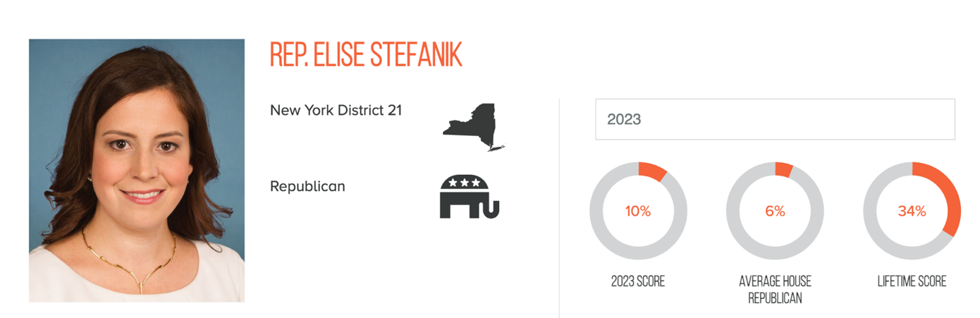

[AFL-CIO, Elise Stefanik, Accessed [8/22/25](https://aflcio.org/scorecard/legislators/elise-stefanik)]

#### 2022: STEFANIK RECEIVED AN 8% RATING FROM THE AFL-CIO

**2022: Stefanik Received An 8% Rating From The AFL-CIO.** [AFL-CIO, Elise Stefanik, Accessed [9/2/25](https://aflcio.org/scorecard/legislators/elise-stefanik)]

[AFL-CIO, Elise Stefanik, Accessed [9/2/25](https://aflcio.org/scorecard/legislators/elise-stefanik)]

#### 2021: STEFANIK RECEIVED A 10% RATING FROM THE AFL-CIO

**2021: Stefanik Received A 10% Rating From The AFL-CIO.** [AFL-CIO, Elise Stefanik, Accessed [9/2/25](https://aflcio.org/scorecard/legislators/elise-stefanik)]

[AFL-CIO, Elise Stefanik, Accessed [9/2/25](https://aflcio.org/scorecard/legislators/elise-stefanik)]

#### 2020: STEFANIK RECEIVED A 37% RATING FROM THE AFL-CIO

**2020: Stefanik Received A 37% Rating From The AFL-CIO.** [AFL-CIO, Elise Stefanik, Accessed [9/2/25](https://aflcio.org/scorecard/legislators/elise-stefanik)]

[AFL-CIO, Elise Stefanik, Accessed [9/2/25](https://aflcio.org/scorecard/legislators/elise-stefanik)]

#### 2019: STEFANIK RECEIVED A 62% RATING FROM THE AFL-CIO

**2019: Stefanik Received A 62% Rating From The AFL-CIO.** [AFL-CIO, Elise Stefanik, Accessed [9/2/25](https://aflcio.org/scorecard/legislators/elise-stefanik)]

[AFL-CIO, Elise Stefanik, Accessed [9/2/25](https://aflcio.org/scorecard/legislators/elise-stefanik)]

#### 2018: STEFANIK RECEIVED A 33% RATING FROM THE AFL-CIO

**2018: Stefanik Received A 33% Rating From The AFL-CIO.** [AFL-CIO, Elise Stefanik, Accessed [9/2/25](https://aflcio.org/scorecard/legislators/elise-stefanik)]

[AFL-CIO, Elise Stefanik, Accessed [9/2/25](https://aflcio.org/scorecard/legislators/elise-stefanik)]

#### 2017: STEFANIK RECEIVED A 39% RATING FROM THE AFL-CIO

**2017: Stefanik Received A 39% Rating From The AFL-CIO.** [AFL-CIO, Elise Stefanik, Accessed [9/2/25](https://aflcio.org/scorecard/legislators/elise-stefanik)]

[AFL-CIO, Elise Stefanik, Accessed [9/2/25](https://aflcio.org/scorecard/legislators/elise-stefanik)]

#### 2016: STEFANIK RECEIVED A 63% RATING FROM THE AFL-CIO

**2016: Stefanik Received A 63% Rating From The AFL-CIO.** [AFL-CIO, Elise Stefanik, Accessed [9/2/25](https://aflcio.org/scorecard/legislators/elise-stefanik)]

[AFL-CIO, Elise Stefanik, Accessed [9/2/25](https://aflcio.org/scorecard/legislators/elise-stefanik)]

#### 2015: STEFANIK RECEIVED A 33% RATING FROM THE AFL-CIO

**2015: Stefanik Received A 33% Rating From The AFL-CIO.** [AFL-CIO, Elise Stefanik, Accessed [9/2/25](https://aflcio.org/scorecard/legislators/elise-stefanik)]

[AFL-CIO, Elise Stefanik, Accessed [9/2/25](https://aflcio.org/scorecard/legislators/elise-stefanik)]